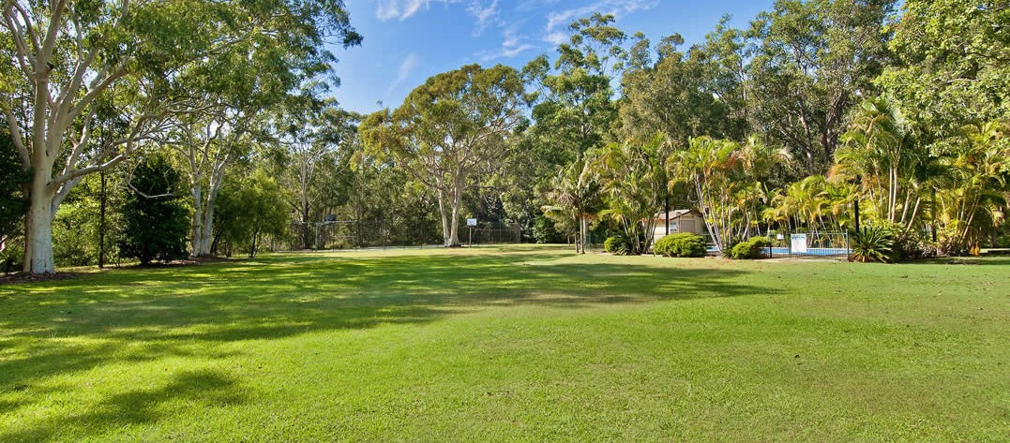

2026 Port Macquarie ‘Bonny Hills’ Easter Camp

Dates

Friday 3rd APRIL 2026 Monday 6th April 2026
Name & Location The Francis Retreat 2 Thomson Place

Bonny Hills NSW 2445
All enquiries to Bev Frost
Ph: 0421113366
Email
gregfrost48@bigpond.com

The camp is catered for and people are expected to stay in the camp accommodation.

Check in from 10am on Friday 3rd APRIL. You’ll enjoy top quality 3 meals a day. Your first meal will be Friday Dinner 5.30pm. Please bring your own morning & afternoon tea. Tea and Coffee available all day. Your last meal will be Monday Breakfast Followed by a meeting and morning tea.

Dormitory style accommodation for Families designed to sleep 8 guests with its own en-suite bathroom. You will need to bring your own bed linen and towels. 1family per Dorm.

Singles up to 8 in a dorm. Bring your own bedding and other linen.

Two bedroom Cabins for couples, all linen included. Value for money Twin Share. (2 Couples)

Please act responsible if you are feeling unwell before camp.

Benefits of choosing Port Macquarie Easter Camp 2026 include:

- Camp will be occupied exclusively by us
- Tennis, pool and basketball on site
- 10 minutes walk to surf beach
- Great for families, no cooking for mums
- Great for Youngies
- Australia’s best climate
- Great opportunity for outreaching
- 4.5 hours from Sydney
- Great for just relaxing and enjoying fellowship

All bookings require $100 deposit no later than 30th January. Payment option is by direct deposit, details on registration form. To secure your booking at camp please contact us immediately. Final payment required by 20th March 2026. If you need financial assistance, please don’t hesitate to speak with your Pastor.

Adult Fee - $540 per person (Dorm)
Children age 6 – 12yrs $165 (Dorm)
Children 0-5, Free (Dorm)

Cabin Per/Couple Twin Share: $1080 (per couple)
= $2160
call. Bev 0421113366

